Connor Johnson

CS 1675

Assignment 6

1.

a) w = [0.0445 0.0116 -0.0050 0.0003 -0.0002 0.0264 0.3524 0.0063], b = -2.7182

c) Test Data

|  |  |  |
| --- | --- | --- |
|  | Predicted Negative | Predicted Positive |
| True Negative | 142 | 19 |
| True Positive | 26 | 42 |

Error = 0.1965

Sensitivity = 0.6176

Specificity = 0.8820

Training Data

|  |  |  |
| --- | --- | --- |
|  | Predicted Negative | Predicted Positive |
| True Negative | 299 | 40 |
| True Positive | 85 | 115 |

Error = 0.2319

Sensitivity = 0.5750

Specificity = 0.8820

d) Overall, this model performed much better than the logistic regression. The errors for both the training and test set are about 0.1 lower. This model performed much better at predicting negatives which is seen in the specificity values. Because of this, it had much lower error.

2.

**Logistic Regression**

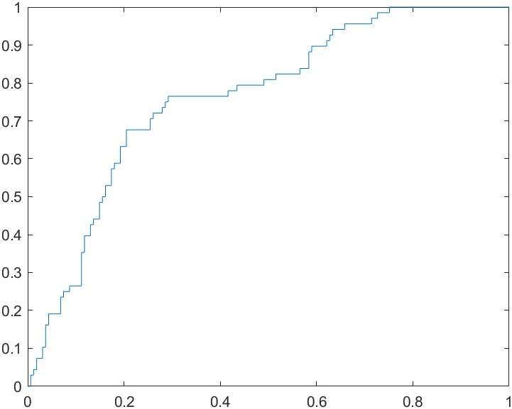

AUC = 0.7633

**SVM Model**

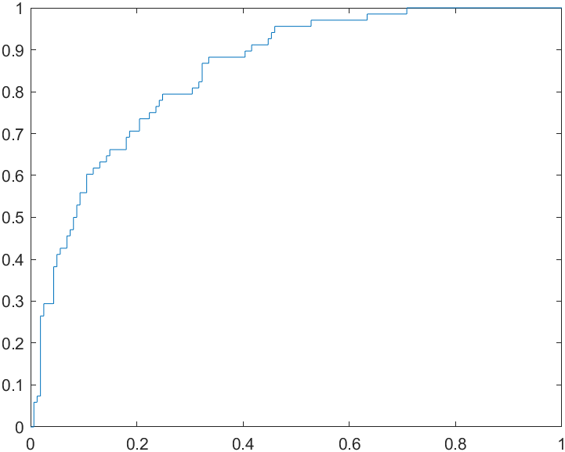

AUC = 0.8497

THE ROC curves and their AUC values show that the SVM model performs better than the logistic regression. A perfect model would have an AUC of and the SVM Model’s AUC is about 0.1 greater than the logistic AUC.

3.

|  |  |  |
| --- | --- | --- |
| Hidden Units | Train Error | Test Error |
| 0 | 0.2468 | 0.2358 |
| 2 | 0.22375 | 0.2489 |
| 3 | 0.2301 | 0.2445 |
| 5 | 0.2226 | 0.1921 |
| 10 | 0.2319 | 0.2096 |

The neural network performed slightly better with the hidden layers. It continued to improve as more units were added to the hidden layer as seen in the error values above